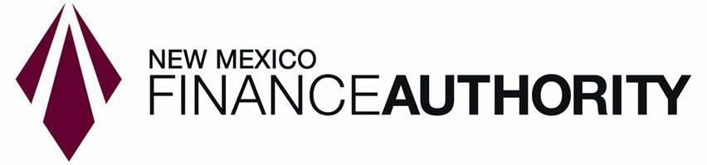

QUESTIONS & ANSWERS TO

REQUEST FOR PROPOSALS

Loan Risk Rating Score Cards and Measurement Implementation and Consultation Services

DATE RFP ISSUED: December 20, 2023

DATE OF ANSWERS: January 12, 2024
Question: While the base system of CASH Suites is leveraged for credit analysis, it is mentioned that these could change. If the goal is to streamline and modernize this tech stack, would NMFA be open to expanding the scope to include a replacement that has built in connectivity to scorecards vs utilizing an API?

Answer: The NMFA would be open to contemplating such a proposal. Integration of systems is key.

Question: Is NMFA looking for simply Advisory Services on the scorecards or are you also considering finding a solution to house and manage these scorecards? In addition, is NMFA looking to manage this infrastructure or the vendor?

Answer: Ideally, a proposal would include the housing and management of the scorecards, as well as a NMFA managed solution.

Question: Is the intent for the scorecard (specifically project finance) to serve as the cash flow engine? Or do you have a separate cash flow engine and need the scorecard only for qualitative purposes?

Answer: The intent is for the scorecard to serve as a qualitative measure and provide a baseline for the monitoring of risk.

Question: What is NMFA’s budget range allocated to this project?

Answer: The NMFA believes it has budgeted adequate resources for this project. The final budget will be dependent upon proposals received, best and final offers, and negotiation of final terms and conditions.

Question: Within item B 1.0, the RFP states: “loans made to i) public borrowers”. This refers to loans to munis, agencies, etc. rather than public (listed) firms, correct?

Answer: Yes

Question: What is the rough percentage of current borrowers that provided, or could provide, financial statements, and what type of data do you receive or require (pro forma projections, audited financials, others)?

Answer: The NMFA requires routine financials and audits for its entire portfolio. The one exception is its Covid-related recovery portfolio wherein such borrowers initially supplied tax returns.

Question: How much historical (or other) data does NMFA have regarding past loan performance, that could be used in scorecard calibration? Specifically, have you kept record of defaults and realized losses on defaulted projects?

Answer: NMFA has such data.

Question: Is there a fixed deadline for completion of any of the components of this project?

Answer: Not at this time.

Question: What type of loan portfolio stress tests is the NMFA envisioning (interest rate shocks, credit cycles, single loan failures?

Answer: That is correct, however the NMFA seeks additional input on hypothetical, historical and simulated scenarios.

Question: Does NMFA currently use a single consistent rating scale for the credit quality of all borrowers? Would the project include the development/calibration of a new rating scale?

Answer: Historically, the NMFA has tailored rating scales to the particular program. Thus, NMFA does not have one consistent rating scale across all loan programs. The contemplated project would include the development/calibration of a new rating scale.

Question: Within item C 2.0, the RFP states “Apply risk ratings/scorecards to existing portfolio in a ‘bulk scorecard process’. Is this a one-time conversion of the existing portfolio to the new scorecard/ risk rating methodology? Or the ability to run/risk rate the existing portfolio on an ongoing basis (quarterly, semi-annual)?

Answer: The NMFA contemplates an initial bulk rating, with the ability to re-rate the portfolio as conditions warrant. That said, the existing portfolios should be subject to stress testing.

Question: Can NMFA provide some detail on the scope of services provided by existing NMFA scorecard input spreading systems, such as Cash Suites? Would scorecards developed under this project be able to source all inputs from these existing systems and if so, via API or other means?

Answer: Cash Suites without development will not integrate with other systems. Any data would be available for manual input.

Question: Given that NMFA may be migrating to new systems, will sufficient NMFA systems integration under this contract will be achieved by making all relevant scorecard output data available via API access to a cloud data storage solution of the vendor’s choosing, or by other means?

Answer: The NMFA is open to various solutions.

